Low Level Design Template

DMT/AD06/TMP

Project Code | Group 5
Project Name | Faculty Information System

Prepared/Modified by | Role | Date of Preparation
Akansha Singh | Software Engineer | 10-05-2019
Reviewed by | Role | Date of Review
Revati Chaudhari | Software Engineer | 11-05-2019
Approved by | Role | Date of Approval
Manish Rajhans | Batch Mentor | 13-05-2019
Circulation List | aayushi.a.jain@capgemini.com  kapil.ramnani@capgemini.com  revati.chaudhari@capgemini.com  shraddha.dambalkar@capgemini.com  akansha.singh@capgemini.com  challarapu.manisha-manvi@capgemini.com
Version Number | 1.0

Table of Contents

1. Description Of The Unit 3
2. References…………………...…………………………….…………………………………….5
3. Dependencies / Assumptions……………………………………………………………………6
4. Class Diagrams…………………………………………………………………...………….......7

5. Sequence Diagrams…………………………….………………………………………………..8
6. Design Components……………………………………………………………………………..9
6.1 List Of UI Components…………………………………………………………………….9
6.2 List Of Design Classes……………………………………………………………………..9
7 Re-Usable Routines/Components……………………………………………………………….10
8. Messages……………………………………………………………………………………….11
9. Configuration Files…………………………………………………………………..…………12
10. Crud Matrix Table…………………………………………………………………………….13
11. Data Mapping Matrix………………………………………………………………………...14
12. Action Flow Matrix…………………………………………………………………………..15
REVISION HISTORY OF THE WORK PRODUCT…………………………………………….16

Description Of The Unit

This document outlines a mini project for the .NET Line of Technology (LOT). The project is to develop Faculty Information System. This document contains the requirements, work flow of the system and gives guidelines on how to build the functionality gradually in each of the course modules of the .NET LOT.
Faculty Information System will hold the following information:
- Faculty Personal Information
- Work History for each faculty member.
- Publication archiving and retrieval for each faculty.
- Degrees earned by the faculty members.
- Grants/Awards given to faculty members.
- Courses taught by the Faculty members.
Users of the System will be: Faculties, Students, Administrator
Role of Faculties:
- Login to System
- Add Personal Information, Work History, Publications and Grant Information, Courses taught by Faculty
- Update Information
- View Information

Role of Administrator
- Login to System
- Create new users ,Update the Role
- Update the current Work information of Faculty
- Add Courses and Subjects
- Update/Delete Courses and Subjects
- Add/Update/Delete Department
- Add/Update/Delete Designation
Role of Student
- Search the faculty publication and view the information

System Requirement Specifications:

- Intel Pentium 4 and above Windows 2007, 2008 and 2010
- Memory 4 GB
- Internet Explorer 8.0 or higher
- SQL Server 2012 client and access to SQL Server 2012 server
- Visual Studio 2017

References
.
- Draw.io for UML Diagrams
- C# Corner for MVC
- W3Schools for HTML/CSS/Bootstrap
- Stack Overflow for Errors

Dependencies / Assumptions

No dependencies.

Class Diagrams

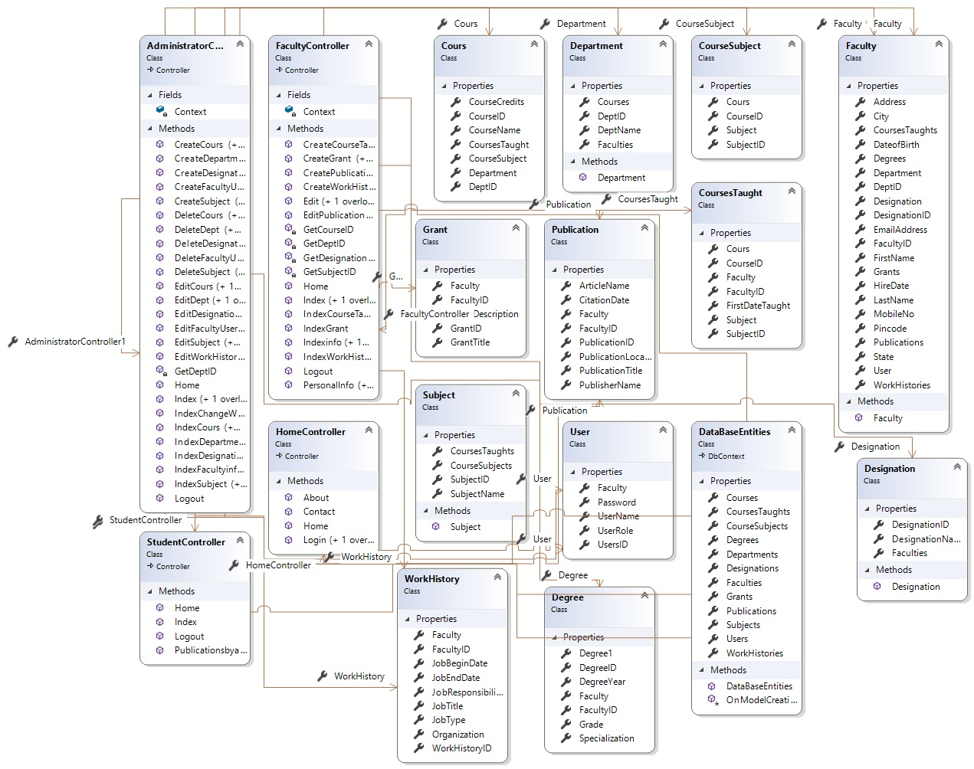

Sequence Diagrams

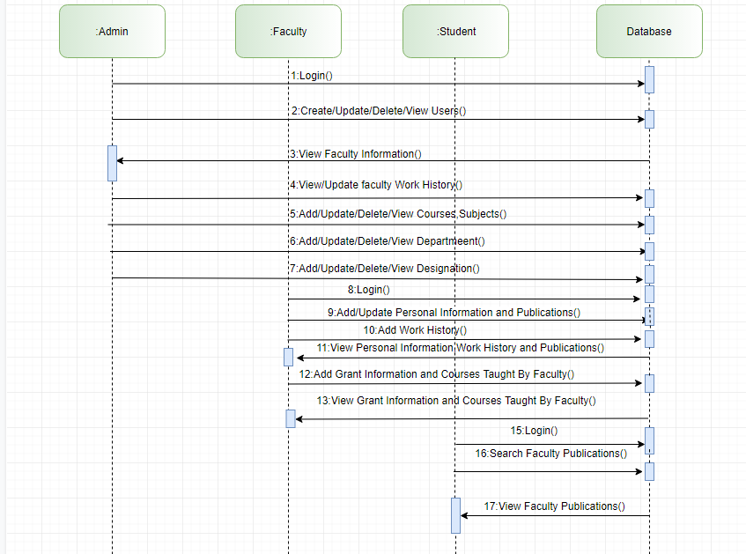

Design Components

List Of UI Components

- Textbox
- Button
- Dynamic Dropdown List
- Dropdown List

List Of Design Classes

- Users Class
- Faculty Class
- Publications Class
- Work History Class
- Grants Class
- Courses Class
- Department Class
- Designation Class
- Subjects Class
- Course Subject Class
- Courses Taught Class

Re-Usable Routines/Components

1. Layout
2. Bootstrap
3. Views
4. Entity

Messages

#. | Type | Message Text
1. | <Warning/Information/Validation/Error> | Username is required  Password is required  Joining Date not valid  Article Name required  Grant Description required

Configuration Files

File Name | Path | Description
Faculty Information System | C:\Users\revchaud\Desktop\FIS_174867 | Project folder
Faculty Information System | http://fis-webapp.azurewebsites.net | Cloud

Crud Matrix Table

# | Table Name | Create | Read | Update | Delete
1 | Faculty | Yes | Yes | Yes | No
2 | User | Yes | Yes | Yes | Yes
3. | Work History | Yes | Yes | Yes | No
4 | Publication | Yes | Yes | Yes | No
5 | Department, Designation | Yes | Yes | Yes | Yes
6 | Course | Yes | Yes | Yes | Yes
7 | Grants | Yes | Yes | Yes | No
8 | Subject | Yes | Yes | Yes | Yes
9 | Course Taught | Yes | Yes | No | No

Data Mapping Matrix

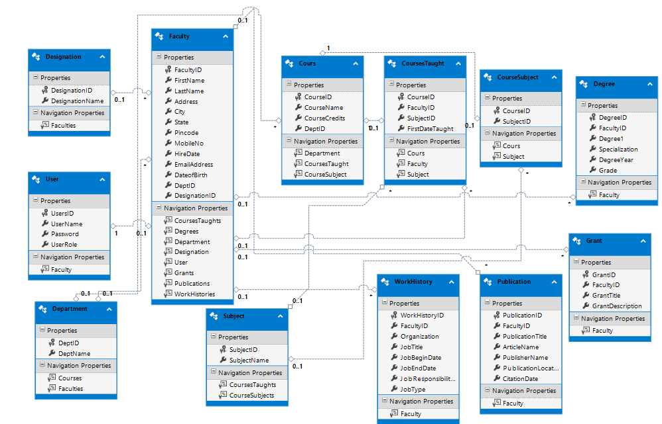

Action Flow Matrix

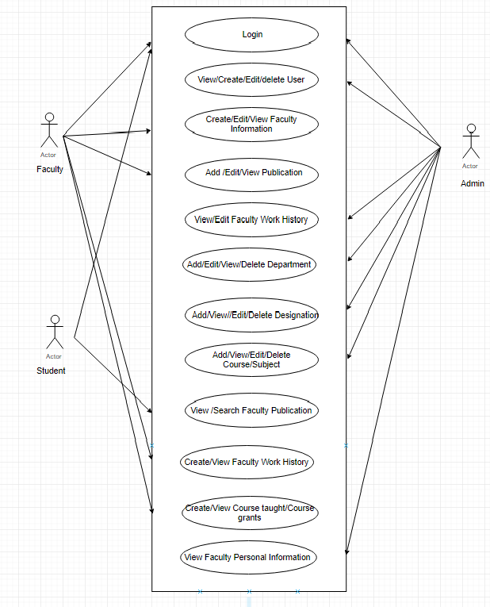
REVISION HISTORY OF THE WORK PRODUCT

# | Date | Version # | Section Changed | Details of changes made | Approved By
1 | 14-05-2019 | 1.0 |  |  | Manish Rajhans

